Name of Student: HARPAL BIDAWAT | PRN:25070122080
Semester: III | Year: AY 2026-27
Subject: Programming with Java
ASSIGNMENT No: 26
TITLE: Write a Java program to create and execute multiple threads using the Runnable
interface.
Problem Statement
Write a Java program to create and execute multiple threads using the Runnable interface.
Learning Objectives
To create multiple threads using the Runnable interface.
Programme
1. Create a program using Runnable to run two tasks simultaneously.
2. Create a Java program using the Runnable interface where two tasks run simultaneously: one thread performs deposit operations, and another performs withdrawal operations, both displaying results concurrently.

1-

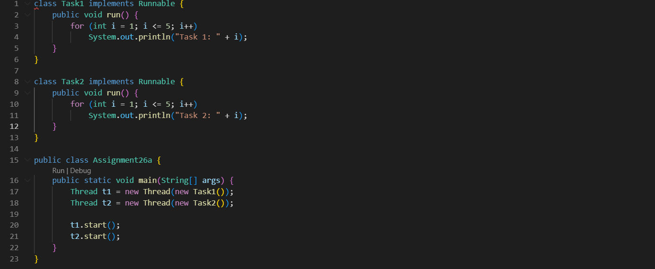

2-
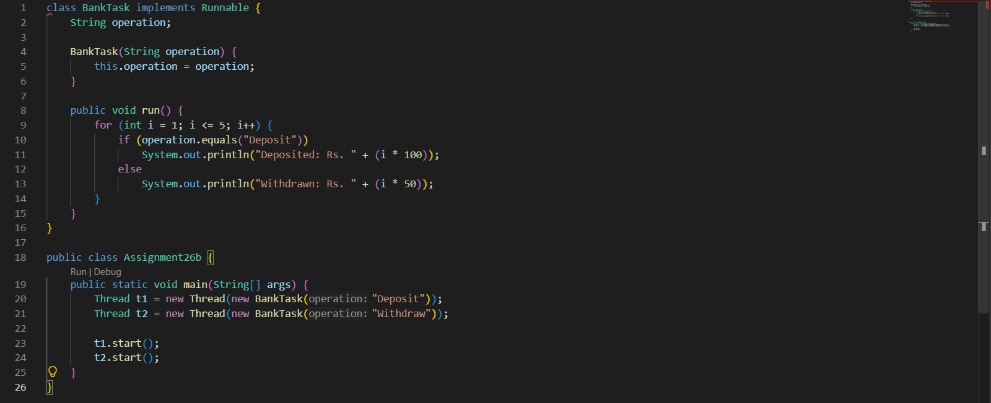
Output
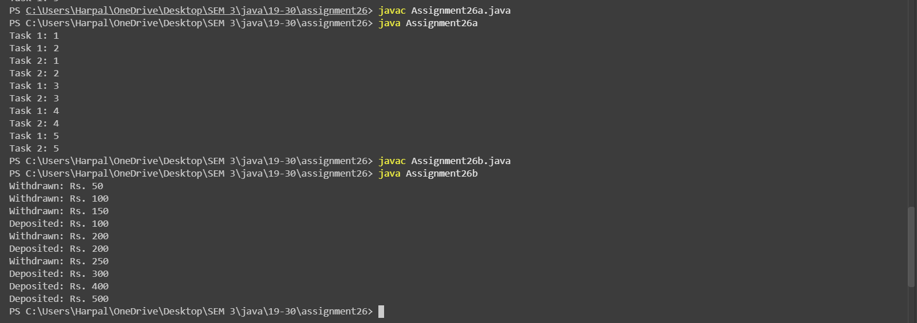
Conclusion
Conclusion: The programs demonstrate multithreading using the Runnable interface in Java. Two tasks execute concurrently in separate threads, and the deposit and withdrawal program illustrates how multiple operations can run simultaneously.

